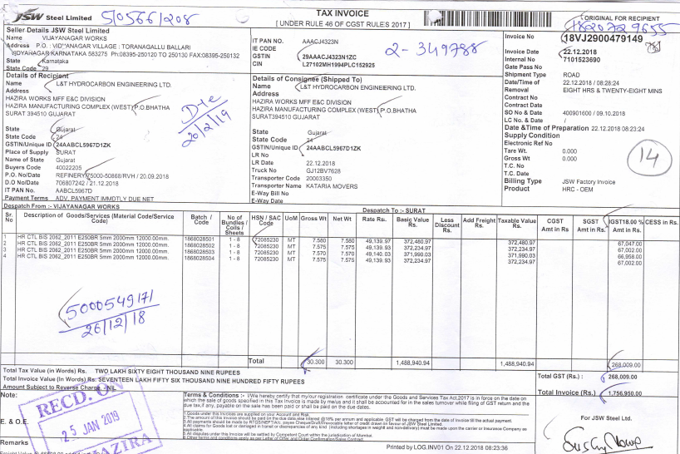

Vendor’s Name & Address, State and State Code

**Stamp on Signature of the Vendor.**

**RCM-YES/NO**

Consignee GSTN Number. Truck number must be mentioned on invoice or invoice number to be mentioned on LR for cross Ref.

**Vendor GSTN Number.**

**HSN Code for Material and SAC code for Service**

Billed to Name, Billed to Address, LTHE GSTN Number, Place of Supply, State Code and State Name.

**Invoice Numbers should not be more than 16 characters.**

**“Original For Recipient” is Mandatory**

**“Tax Invoice” is mandatorily to be mentioned on the top of the invoice.**

Purchase Register run

Errors

IRIS format

Incl utilization

Match

Garnet tool – from IRIS

Check – invoice no., rate,

Upload to iris

Get2a

Bulk upload reco run

